CartCycle: An Explainable End-to-End Analytics Pipeline for Customer Segmentation, Churn Prediction and Demand Forecasting in Online Retail
A Project Report Submitted in the partial fulfillment of the requirements for the award of the degree of
BACHELOR OF TECHNOLOGY
In
DEPARTMENT OF COMPUTER SCIENCE AND ENGINEERING
By
Dhanya Sri | : 2420030023
Tanvi | : 2420030507
Sarvani | : 2420030367

Under the Esteemed Guidance of
Bonagani Prathusha
Department of Computer Science and Engineering, Koneru Lakshmaiah Education Foundation, Bowrampet, Hyderabad-500043, Telangana, India.
Department of COMPUTER SCIENCE AND ENGINEERING
AY- 2026-2027
Semester: 5
K L (Deemed to be) University
DEPARTMENT OF COMPUTER SCIENCE AND ENGINEERING
K L (Deemed to be) University
DEPARTMENT OF COMPUTER SCIENCE AND ENGINEERING
Declaration
The Project Report entitled “CartCycle: An Explainable End-to-End Analytics Pipeline for Customer Segmentation, Churn Prediction and Demand Forecasting in Online Retail” is a record of Bonafide work of Dhanya Sri – 2420030023, Tanvi – 2420030507, Sarvani – 2420030367 submitted in partial fulfillment for the award of B. Tech in Computer Science and Engineering to the K L University. The results embodied in this report have not been copied from any other departments/University/Institute.

Dhanya Sri – 2420030023
Tanvi – 2420030507
Sarvani – 2420030367
K L (Deemed to be) University
DEPARTMENT OF COMPUTER SCIENCE AND ENGINEERING
CERTIFICATE
This is to certify that the project based report entitled “CartCycle: An Explainable End-to-End Analytics Pipeline for Customer Segmentation, Churn Prediction and Demand Forecasting in Online Retail” is a bonafide work done and submitted by Dhanya Sri – 2420030023, Tanvi – 2420030507, Sarvani – 2420030367 in partial fulfillment of the requirements for the award of the degree of BACHELOR OF TECHNOLOGY in Department of Computer Science and Engineering, K L (Deemed to be University), during the academic year 2026-2027.

Signature of the Guide
Signature of the Course Coordinator | Signature of the HOD
ACKNOWLEDGEMENT
The success in this project would not have been possible but for the timely help and guidance rendered by many people. We wish to express our sincere thanks to all those who have assisted us in one way or the other for the completion of our project.
Our greatest appreciation to our Course Coordinator [Course Coordinator Name] and our guide [Guide Name], Department of Computer Science and Engineering, which cannot be expressed in words, for the tremendous support, encouragement and guidance given for this project.
We express our gratitude to [HOD Name], Head of the Department of Computer Science and Engineering, for providing us with adequate facilities, ways and means by which we were able to complete this project.
We thank all the members of the teaching and non-teaching staff, and all who have assisted us directly or indirectly in the successful completion of this project. Finally, we sincerely thank our parents, friends and classmates for their kind help and cooperation during our work.

Dhanya Sri – 2420030023
Tanvi – 2420030507
Sarvani – 2420030367
Abstract
Online retailers generate large volumes of transactional data, yet small and mid-sized businesses still analyse customers, sales and inventory in separate tools. This delays decisions and hides the link between acquiring a customer, retaining that customer and the revenue that follows. CartCycle is a full-cycle e-commerce analytics pipeline that unifies customer analytics and sales analytics in one explainable system.
The pipeline covers data validation and cleaning, recency–frequency–monetary (RFM) feature engineering, K-means customer segmentation, gradient-boosted churn prediction with feature-importance explanations, market-basket mining, time-series demand forecasting and a no-code dashboard. The dashboard converts model output into three concrete actions: retain at-risk customers, bundle co-purchased products and restock categories with rising demand. A layered architecture keeps one cleaned data source behind every figure, so revenue totals, customer counts and churn scores agree across all views.
The pipeline and dashboard were run on the public CDNOW transaction dataset of 23,502 customers. K-means with k = 3 gives a silhouette score of 0.480, and the churn classifier reaches an accuracy of 0.818, an F1-score of 0.888 and an AUC-ROC of 0.803 on a held-out set. A damped-trend forecaster does not improve on a naive baseline for this single-cohort series (MAPE 27.12% for both), which shows why every forecast is reported against a baseline. The report also discusses privacy, deployment and limitations, and outlines future work on streaming, recommendation and privacy-preserving analytics.
Keywords: E-commerce analytics, customer segmentation, churn prediction, RFM analysis, demand forecasting, business intelligence.
Index
S. No. | Chapters | Topics | Page no.
 |  | Acknowledgement | 4
 |  | Abstract | 5
1 | Introduction | 1.1 Background of the project  1.2 Problem statement  1.3 Scope of the project  1.4 Objective(s)  1.5 Importance of the application  1.6 Target users/audience | 8-10
2 | System Requirements | 2.1 Hardware requirements  2.2 Software requirements  2.3 Development tools and frameworks | 11-12
3 | Technology Stack | 3.1 Front-end  3.2 Back-end  3.3 Database / data storage  3.4 Version control  3.5 APIs or external services | 13-14
4 | System Architecture | 4.1 High-level architecture diagram  4.2 Description of each layer  4.3 Deployment architecture | 15-17
5 | Design | 5.1 Wireframes or mockups  5.2 ER diagram / data schema | 18-20
6 | Implementation | 6.1 Module-wise implementation  6.2 Front-end logic  6.3 Backend logic  6.4 Database connectivity  6.5 API integration  6.6 Authentication & authorization | 21-23
7 | Features | 7.1 List of main features  7.2 How each feature works | 24-25
8 | Testing | 8.1 Postman testing (frontend/backend)  8.2 Integration testing  8.3 Tools used for testing  8.4 Test cases and results | 26-29
9 | Deployment | 9.1 Steps to deploy  9.2 Environment configuration  9.3 Hosting of frontend and backend | 30
10 | Challenges & Limitations | 10.1 Issues faced during development  10.2 Solutions applied  10.3 Current limitations or known bugs | 31
11 | Future Enhancements | 11.1 Planned features  11.2 Possible integrations or optimizations | 32
12 | Conclusion | 12.1 Summary of the project  12.2 What was achieved  12.3 Skills learned during development | 33
13 | References | Books, papers, tutorials, documentation sites used | 34-35
14 | Appendices | Screenshots of the application  Sample code snippets  Installation/setup instructions  User manual or guide  Certifications | 36

CHAPTER 1
Introduction

1.1 Background of the project
Electronic commerce has grown into one of the largest channels of retail, and every click, basket and payment now leaves a digital trace. For a retailer, these traces are an asset only when they are converted into decisions about whom to target, what to stock and when to promote. In practice, many small and mid-sized online businesses keep customer records, order histories and product catalogues in separate spreadsheets, storefront exports and reporting tools. Analysts spend most of their time reconciling these sources by hand, reports arrive late, and the relationship between acquiring a customer, retaining that customer and the revenue that follows remains difficult to see.
The foundations of customer analytics are well established. Recency, frequency and monetary value (RFM) have long been used to describe customer behaviour, and probabilistic models of repeat buying estimate how many customers remain active and what they are likely to spend next [1]–[3]. Clustering methods such as K-means group customers into behavioural segments without labelled data [4], [5], ensemble and gradient-boosted trees perform strongly on tabular customer data [8]–[10], association rule mining reveals products that are bought together [12], [13], and classical time-series models capture trend and seasonality for demand forecasting [14], [15]. Most of these contributions, however, are studied in isolation, and each is usually presented as a single algorithm rather than as part of a working system that a retailer can operate every day.
CartCycle is proposed as a full-cycle answer to this gap: one pipeline that starts from raw transactions and ends in an interactive dashboard that recommends actions, covering both the customer view and the sales view of the business.

1.2 Problem statement
Customer analytics and sales analytics are normally carried out in different tools. This forces business users to switch tools and to trust numbers that were computed on different cleaning rules. The problem addressed by this project can be summarised as follows:
- There is no single governed pipeline that takes a small retailer from raw transactions to concrete actions.
- Acquiring a new customer is generally more costly than retaining an existing one, so at-risk customers need to be identified early, yet churn models are rarely connected to the rest of the business reports.
- Poorly forecast demand leads either to stock-outs that lose sales or to excess inventory that ties up capital, and forecasts are seldom checked against simple baselines.
- Commercial analytics suites are often priced and configured for large enterprises, which is a barrier for smaller sellers.
- Predictions that cannot be explained are rarely acted upon.

1.3 Scope of the project
The scope of CartCycle covers the complete path from raw order data to a recommended action. In scope are: data validation and cleaning; RFM feature engineering; K-means segmentation with plain-language segment labels; customer lifetime value ranking; churn prediction with feature-importance explanations; revenue tracking; Apriori market-basket mining; weekly demand forecasting with baseline comparison; and an interactive dashboard with an action layer (retain, bundle, restock).
The system is evaluated on one public dataset, the CDNOW transaction sample (69,324 transactions, 23,502 customers, January 1997 to June 1998). Because this dataset has no product or basket information, the basket-mining module could not be evaluated on it. Streaming scoring, personalised recommendation, survival models, A/B testing and federated learning are outside the current scope and are listed as future work in Chapter 11.

1.4 Objective(s)
- To design a modular, layered pipeline that shares one cleaned data source between customer analytics and sales analytics.
- To build an explainable customer branch that combines RFM segmentation, lifetime value ranking and churn prediction.
- To build a sales branch that combines revenue tracking, basket mining and baseline-checked forecasting.
- To provide a no-code dashboard whose action layer converts model output into retention, bundling and restocking recommendations.
- To evaluate the segmentation, churn and forecasting modules on a public retail dataset, with an honest account of where the approach does and does not help.
- To handle customer data responsibly through pseudonymous keys, aggregated outputs and monitored, rollback-capable models.

1.5 Importance of the application
The importance of the application follows from five observations. First, the separation of customer analytics from sales analytics forces business users to trust numbers computed on different cleaning rules, so a single governed pipeline improves consistency and saves analyst time. Second, early identification of at-risk customers is economically important, particularly for retailers whose margins are thin. Third, reliable demand forecasts reduce stock-outs and excess inventory. Fourth, an open-source-based platform lowers the barrier for smaller sellers who cannot afford enterprise suites. Finally, CartCycle treats interpretability and an explicit action layer as design requirements, because predictions that cannot be explained are rarely acted upon.

1.6 Target users/audience
- Small and mid-sized online retailers who need analytics without a dedicated data-science team.
- Marketing and retention teams who use the priority retention list and segment labels to plan campaigns.
- Merchandising and inventory planners who use the forecast, bundle and restocking panels.
- Business analysts and managers who read the headline indicators and drill down from a number to its cause and then to a decision.
- Students and researchers who want a transparent, auditable reference implementation of an end-to-end retail analytics pipeline.

CHAPTER 2
System Requirements

2.1 Hardware requirements
CartCycle is written in Python using widely available libraries and runs on an ordinary computer. The recommended configuration for running the pipeline and the dashboard on a dataset of the size of CDNOW is given in Table 2.1. Larger stores need proportionally more memory.
Component | Recommended requirement
Processor | Dual-core 2.0 GHz or higher (quad-core preferred for faster model training)
Memory (RAM) | 8 GB (4 GB is sufficient for the CDNOW sample)
Storage | At least 2 GB free for the environment, datasets, fitted models and exports
Display | 1366 × 768 or higher, for the dashboard layout
Network | Needed only to install packages and to access a hosted dashboard
Table 2.1 Hardware requirements

2.2 Software requirements
Component | Requirement
Operating system | Windows, Linux or macOS
Language | Python 3
Data handling | Pandas and NumPy
Machine learning | scikit-learn [17] (K-means, silhouette score, gradient-boosted trees, metrics)
Time-series | statsmodels [18] (exponential smoothing)
Visualisation | Matplotlib for evaluation figures; an interactive dashboard front-end
Browser | A current web browser (Chrome, Edge, Firefox) to view the dashboard
Table 2.2 Software requirements

Functional requirements
- Load order data and validate data types and ranges; remove exact duplicates; separate cancelled and returned orders; standardise dates and currency.
- Derive customer features (REC, FREQ, MON, AOV, QTY, TENURE) and the churn label.
- Segment customers, predict churn and rank customers by value at risk.
- Aggregate sales by day, week and month, mine product bundles and forecast weekly revenue against baselines.
- Present all results in a filterable dashboard and export the priority retention list as a CSV file.

Non-functional requirements
- Traceability: every dashboard figure must trace back to a single cleaned source.
- Modularity: each module can be retrained or replaced without disturbing the others.
- Responsiveness: the presentation layer only reads finished results, so a slow model run never blocks a user browsing the dashboard.
- Privacy and auditability: pseudonymous customer keys, aggregated outputs by default, and code small enough to be audited by a small team.

2.3 Development tools and frameworks
The pipeline is developed entirely in Python. Pandas and NumPy handle data preparation, scikit-learn provides clustering, classification and evaluation, and statsmodels provides the exponential smoothing forecaster. The dashboard is a Python-based interactive web application with a sidebar for data source and filters and tabbed views (Overview, Segments, Churn, Sales & forecast, Data quality). A code editor or notebook environment is used for development, and Git is used to version the code. Using open-source tools keeps software cost low and allows the code to be audited by a small team.

CHAPTER 3
Technology Stack

3.1 Front-end
The front-end is an interactive, no-code web dashboard written in Python. It has a left sidebar for choosing the data source (the public CDNOW sample or an uploaded CSV file) and for filtering by date range and customer segment, an indicator row (revenue, orders, average order value, customers, average churn risk), and tabs for the overview, segments, churn, sales and forecast, and data quality. Every chart updates from the same cleaned data. The layout follows the order in which a manager normally reasons, moving from a headline number to its cause and then to a decision.

3.2 Back-end
The back-end is a Python pipeline. Its main components are listed below.
- Pandas and NumPy: validation, cleaning, aggregation and feature engineering.
- scikit-learn [17]: standardisation, K-means clustering, the silhouette score, a gradient-boosted tree classifier [10] and the evaluation metrics (accuracy, precision, recall, F1-score, AUC-ROC).
- statsmodels [18]: damped-trend exponential smoothing for weekly revenue forecasting.
- Apriori algorithm [12]: market-basket mining that reports support, confidence and lift.
- Service layer: scheduled retraining, a model registry with versioned copies of fitted models, monitoring and exports.

3.3 Database / data storage
CartCycle uses a storage layer that acts as the single source of truth. Cleaned tables and the feature store are written to this layer by the ingestion stage, and the analytics engine reads from it to train and score the models. The data model has three linked source tables (orders with line items, customers and products) plus a derived customer feature table, as described in Chapter 5. In the evaluated prototype the CDNOW transaction file is loaded directly; for a production store the same storage layer can be backed by a relational database such as MySQL or PostgreSQL.

3.4 Version control
Git is used for version control of the pipeline code, so that changes to cleaning rules, features and models are tracked and can be reviewed. Fitted models are additionally versioned by the service layer's model registry, so that the previous model version remains available for rollback when error rises above an agreed tolerance.

3.5 APIs or external services
The current implementation does not depend on any paid or external web service. The CDNOW transaction sample is obtained from the open-source Lifetimes package [19], which bundles it, and the only exchange formats are CSV upload for data and CSV download for the priority retention list. A future deployment can connect storefront exports or databases through the ingestion layer without changing the analytics engine.

CHAPTER 4
System Architecture

4.1 High-level architecture diagram
Figure 4.1 shows the overall workflow. Raw orders, customers and products are validated and cleaned, and features are written to a feature store. Cleaned data then flow into two parallel analytical branches that share the same feature store: the customer branch (RFM, K-means, customer lifetime value, churn model) and the sales branch (KPIs, basket mining, time-series forecast). Their outputs are evaluated and explained before being published to the interactive dashboard, which ends in recommended actions: retain, bundle and restock.
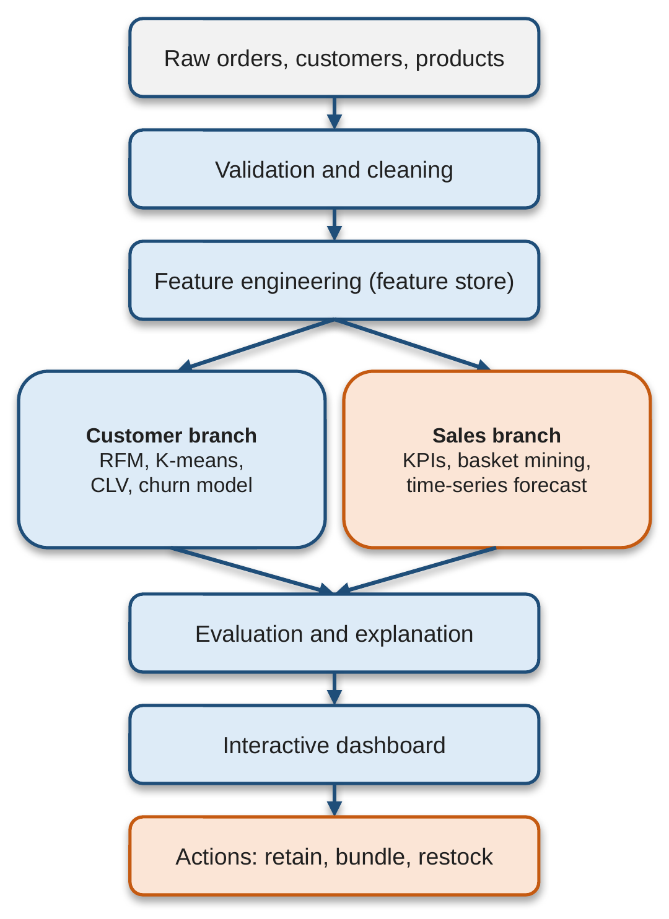
Fig 4.1 Workflow of the proposed CartCycle pipeline
CartCycle is organised as the layered architecture shown in Figure 4.2. Source files enter an ingestion layer that applies the cleaning rules, and the cleaned tables and features are written to a storage layer that acts as the single source of truth. The analytics engine reads from this layer, and a service layer schedules retraining, keeps versioned models and prepares exports. The presentation layer only reads finished results.
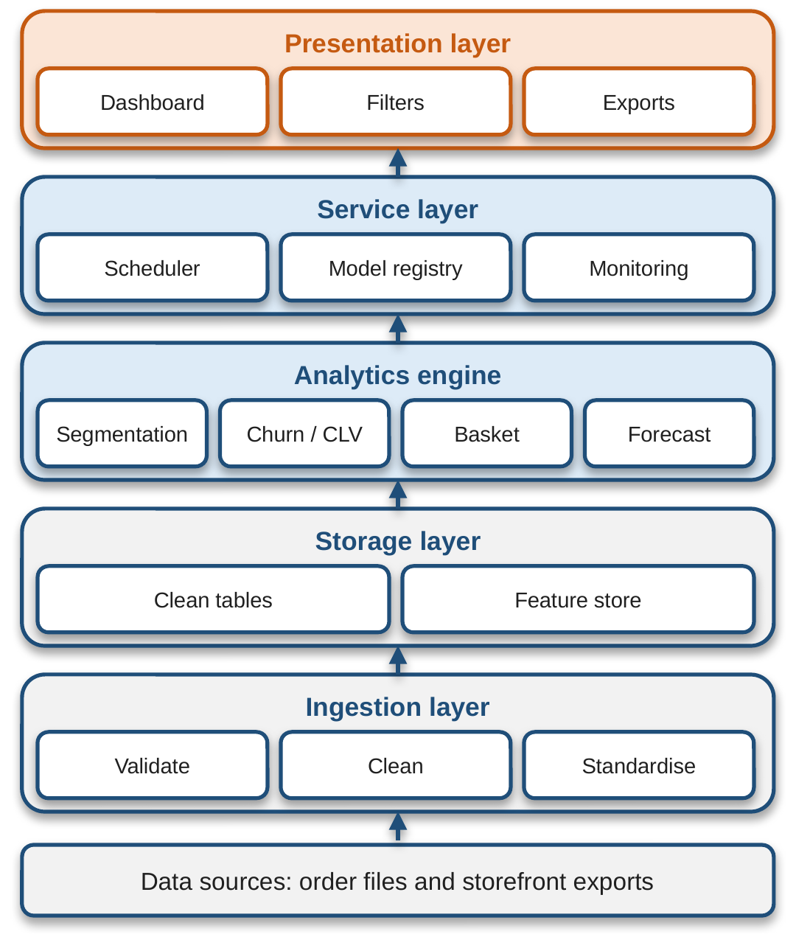
Fig 4.2 Layered architecture of CartCycle

4.2 Description of each layer
Layer | Description
Ingestion layer | Validates data types and ranges, removes exact duplicate rows, separates cancelled and returned orders from completed sales, resolves missing or inconsistent identifiers, and standardises dates and currency fields. Unit price and quantity outliers are flagged rather than deleted, so bulk purchases are not mistaken for errors.
Storage layer | Holds the clean tables and the feature store. It is the single source of truth for every figure on the dashboard.
Analytics engine | Contains four modules: segmentation, churn/CLV, basket mining and forecasting. Each module can be retrained or replaced without disturbing the others.
Service layer | Provides the scheduler for retraining, the model registry with versioned copies of fitted models, and monitoring and exports.
Presentation layer | Dashboard, filters and exports. It only reads finished results, so a slow model run never blocks a user browsing the dashboard.
Table 4.1 Responsibilities of each architectural layer

4.3 Deployment architecture
For deployment, customer features and forecasts are recomputed on a schedule by the service layer. The performance of each deployed model is logged, and when error rises above an agreed tolerance the model is retrained and the previous version remains available for rollback. Because the presentation layer is decoupled from the analytics engine, the dashboard can be hosted on a local machine or on a cloud server, while retraining runs in the background. Details of the deployment procedure are given in Chapter 9.

CHAPTER 5
Design

5.1 Wireframes or mockups
Figure 5.1 shows the wireframe of the main dashboard page. A filter bar (date, region, category, segment) sits at the top, followed by an indicator row with Revenue, Orders, AOV and Churn risk. Below it are the sales trend and forecast chart and the customer segment share chart. At the bottom is the action panel with two parts: at-risk customers, and bundles and restock. The layout follows the way a manager reasons, from a headline number to its cause and then to a decision.
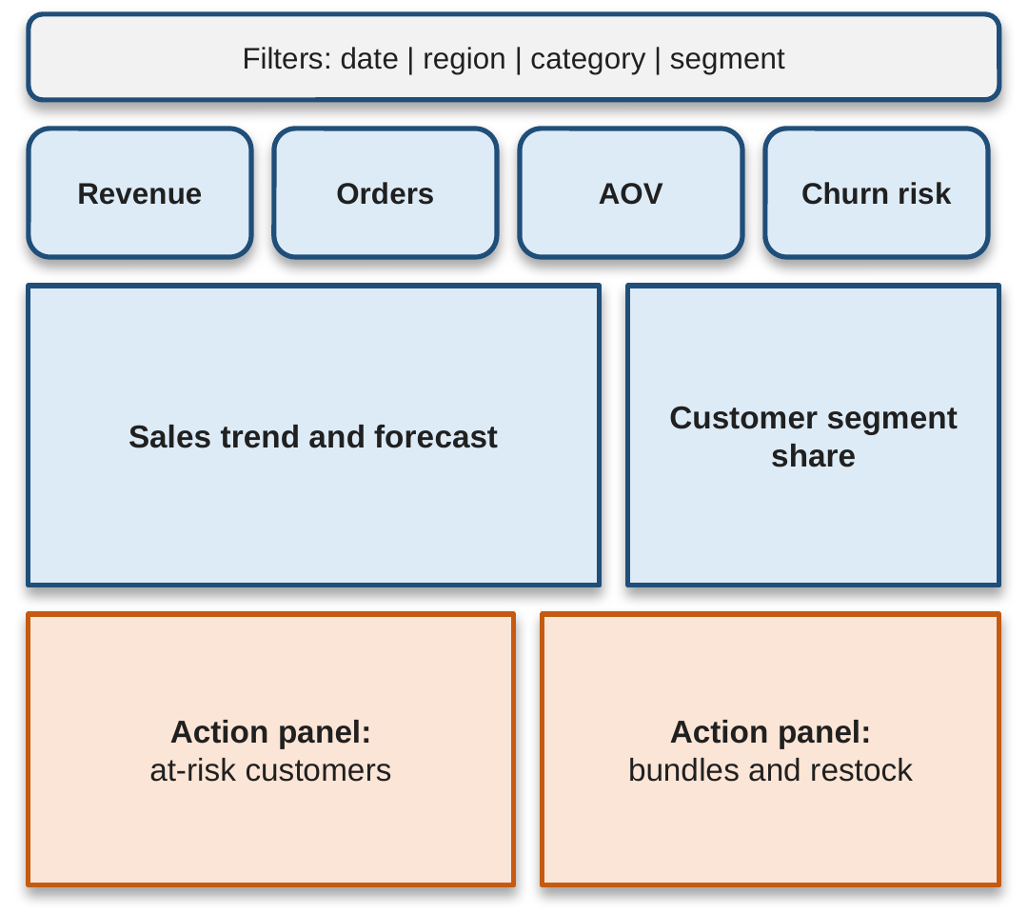
Fig 5.1 Wireframe of the CartCycle dashboard (layout illustration)

5.2 ER diagram / data schema
The data consist of three linked source tables: orders with line items, customers and products. The feature stage derives a customer-level feature table (Table 5.1) that is used by the customer branch. Figure 5.2 shows the logical entity–relationship diagram, and Table 5.2 summarises the entities.
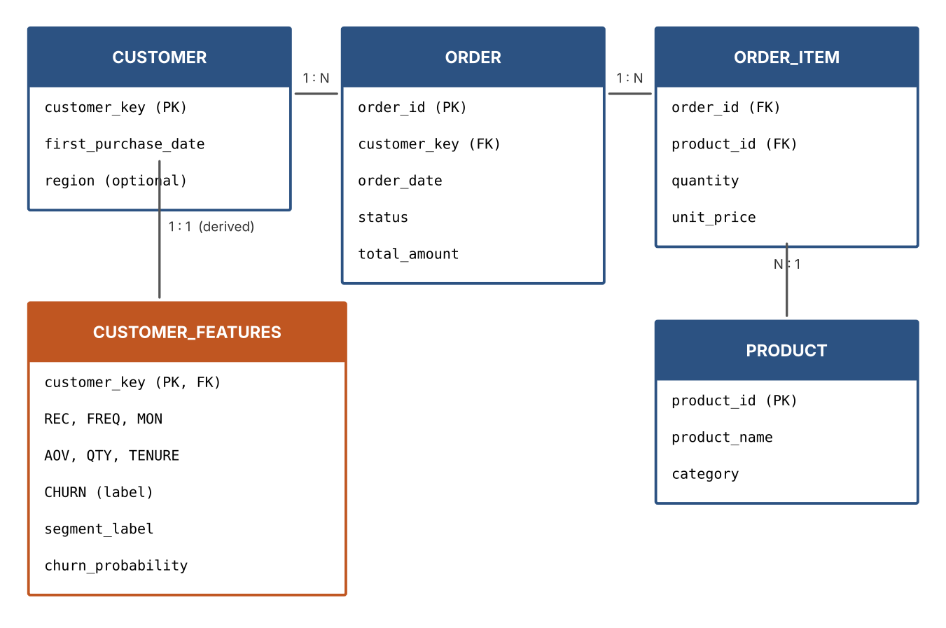
Fig 5.2 Logical ER diagram of the CartCycle data model
Feature | Code | Purpose
Recency (days) | REC | Time since last purchase
Frequency | FREQ | Number of distinct purchase dates
Monetary value | MON | Total spend of a customer
Average order value | AOV | Typical basket size
Quantity | QTY | Total items bought
Tenure (days) | TENURE | Time since first purchase
Product category | CAT | Category-level sales analysis
Churn flag | CHURN | Target label for prediction
Table 5.1 Features used in CartCycle
Entity | Key attributes
CUSTOMER | customer_key (pseudonymous primary key), first purchase date, region (optional)
ORDER | order_id (PK), customer_key (FK), order date, status (completed / cancelled / returned), amount
ORDER_ITEM | order_id (FK), product_id (FK), quantity, unit price (outliers flagged, not deleted)
PRODUCT | product_id (PK), name, category
CUSTOMER_FEATURES | customer_key (PK, FK), REC, FREQ, MON, AOV, QTY, TENURE, CHURN, segment label, churn probability
Table 5.2 Entities of the logical data model
Note: the CDNOW sample contains only customer, date, quantity and amount information, so the PRODUCT and ORDER_ITEM entities are part of the general design but were not populated in the evaluation.

CHAPTER 6
Implementation

6.1 Module-wise implementation

Module 1: Data validation and cleaning
After loading, the pipeline validates data types and ranges, removes exact duplicate rows, separates cancelled and returned orders from completed sales, resolves missing or inconsistent identifiers, and standardises dates and currency fields. Unit price and quantity outliers are flagged rather than deleted. For CDNOW, duplicate and non-positive records are removed, leaving 69,324 transactions from 23,502 customers with a total revenue of $2,495,982.75.

Module 2: Feature engineering
Each customer is described by the days since the last purchase (REC), the number of distinct purchase dates (FREQ), and the total (MON) and average (AOV) amount spent, along with QTY and TENURE (Table 5.1). Features are computed from transactions up to the cut-off date of 31 December 1997.

Module 3: Customer segmentation
The log-transformed RFM features are standardised and clustered with K-means. The number of clusters is chosen by combining the elbow curve with the silhouette score, so that segments are compact and meaningful to marketers. Each segment is given a plain-language label (Loyal, At risk, Dormant) based on its centroid. Customer lifetime value is ranked from historical spend, frequency and tenure.

Module 4: Churn prediction
Churn is formulated as binary classification. A customer is labelled as churned if no purchase occurs between 1 January and 30 June 1998, which gives a churn rate of 77.1%. A gradient-boosted tree classifier is trained on features computed strictly before the cut-off to prevent information leakage. The customers are split into 70% training and 30% test sets with stratification. Feature importance shows which behaviours drive predictions; Shapley-value explanations [11] are the planned extension.

Module 5: Sales analytics
Completed orders are aggregated by day, week and month to produce revenue, order count, units sold and average order value, broken down by category, product and region. Market-basket analysis applies the Apriori algorithm to order baskets and reports support, confidence and lift, so that only associations that are both frequent and stronger than chance are surfaced as bundle suggestions. For demand planning, weekly revenue is forecast with damped-trend exponential smoothing and is always compared against naive and moving-average baselines.

Module 6: Dashboard and action layer
The action layer translates model output into recommendations: customers with a high churn probability and high lifetime value are listed for retention offers, frequently co-purchased products are proposed as bundles, and categories with rising forecast demand are flagged for restocking. The priority retention list is ranked by the value at risk:
Value at risk = churn probability × customer’s total spend

6.2 Front-end logic
The dashboard is the point at which analysis becomes action. The sidebar lets the user choose the data source and filter by date range and customer segment, and every chart updates from the same cleaned data. The main page shows the indicator row, the weekly revenue trend and the segment share (Figure 6.1). Tabs separate the overview, segments, churn, sales and forecast, and data quality views. When a module cannot run on the loaded data, the dashboard says so instead of showing empty output; for example, with CDNOW it reports that bundle suggestions are unavailable because there is no product column.
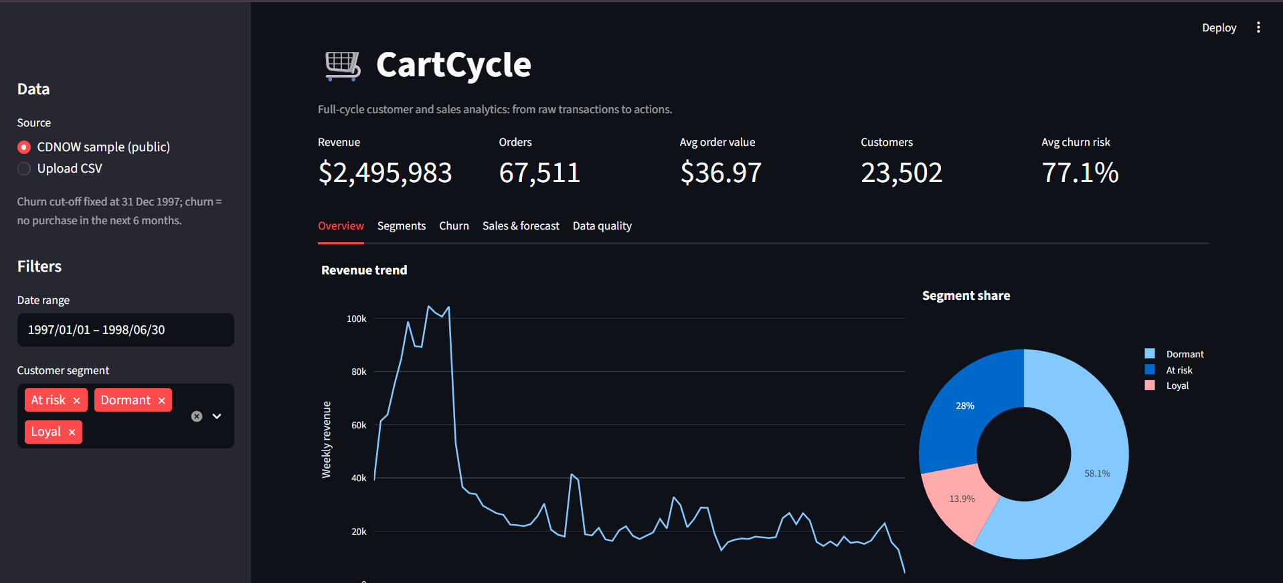
Fig 6.1 Main page of the dashboard on the CDNOW data: indicators, revenue trend and segment share

6.3 Backend logic
The back-end executes the pipeline in a fixed order: ingestion and cleaning, writing to the storage layer, feature engineering, training and scoring of the four analytics modules, evaluation, and publishing of finished results to the presentation layer. Business rules include the 31 December 1997 cut-off date, the six-month inactivity window that defines churn, the stratified 70/30 split, and the rule that every forecast is reported next to a naive and a moving-average baseline. The service layer schedules retraining, keeps versioned copies of fitted models and prepares CSV exports.

6.4 Database connectivity
The ingestion layer writes cleaned tables and features to the storage layer, and every downstream module reads only from it. This guarantees that revenue totals and customer counts agree across every view. Switching the source between the CDNOW sample and an uploaded CSV file changes only the ingestion step.

6.5 API integration
No external API is required. Data enter through file ingestion (CDNOW sample or uploaded CSV) and leave as CSV exports. The modular design means that a storefront API or database connector can be added at the ingestion layer in future.

6.6 Authentication & authorization
Responsible handling of customer data is part of the design. Personal identifiers are replaced with pseudonymous keys before features are created, only the fields required for a stated purpose are retained, and dashboard outputs are aggregated unless a user has permission to view individual lists. Segment labels and risk scores are reviewed for unintended bias. A role-based login for the dashboard is a natural extension of the permission rule above.

CHAPTER 7
Features

7.1 List of main features
- Unified, governed data pipeline with a single cleaned source of truth
- Data validation and cleaning with outlier flagging
- RFM-based customer segmentation with plain-language labels
- Customer lifetime value ranking
- Explainable churn prediction using feature importance
- Revenue tracking by day, week, month, category, product and region
- Market-basket mining with support, confidence and lift
- Baseline-checked weekly demand forecasting
- Interactive dashboard with date and segment filters
- Action layer: priority retention list (CSV export), bundle suggestions and restocking flags
- Privacy-aware design with pseudonymous keys and aggregated outputs
- Scheduled retraining, model versioning, monitoring and rollback

7.2 How each feature works
Feature | User perspective | Technical description
Segmentation | The user sees Loyal, At-risk and Dormant groups with their share of customers. | Log-transformed, standardised RFM features clustered with K-means; k chosen by elbow curve and silhouette score.
Churn prediction | The user sees each customer’s churn risk and which behaviours drive it. | Gradient-boosted tree classifier trained on pre-cut-off features; feature importance reported.
Retention list | The user downloads a ranked list of customers to target with offers. | Customers ranked by churn probability × total spend; exported as CSV.
Sales and forecast | The user sees revenue trends and next-period expectations next to baselines. | Weekly aggregation; damped-trend exponential smoothing vs naive and 8-week moving average.
Bundles | The user sees products worth bundling. | Apriori on order baskets; rules filtered by support, confidence and lift > 1.
Restocking | The user sees categories flagged for rising demand. | Forecast compared with recent demand; a flag is raised only for a rising trend.
Filters | The user restricts every panel by date range and segment. | All charts read the same cleaned tables, so every panel updates consistently.
Table 7.1 Features from user and technical perspectives
Figure 7.1 shows the action layer. The priority retention list ranks customers whose churn probability is high by the value at risk and can be exported as a CSV file for campaign teams. The restocking panel compares the forecast with recent demand and, for CDNOW, raises no flag. Because CDNOW contains no product column, the bundle panel reports that suggestions are unavailable.
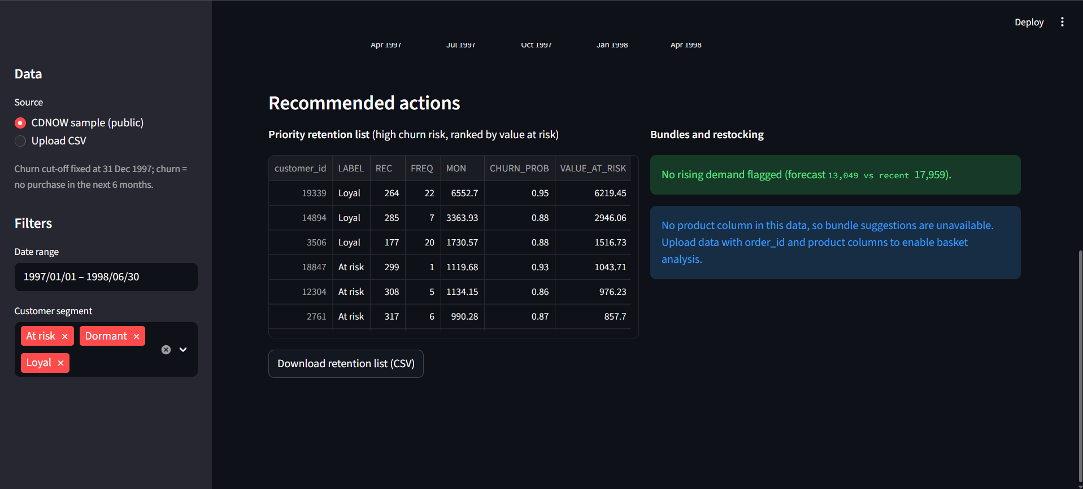
Fig 7.1 Action layer: priority retention list with CSV export, and the restocking and bundle panel

CHAPTER 8
Testing

8.1 Postman testing (frontend/backend)
CartCycle in its current form is a Python pipeline with a dashboard and does not expose a REST API, so Postman-based API testing is not applicable. Testing was instead carried out at the module level (data cleaning, segmentation, churn, forecasting) and end to end through the dashboard, as described below. If a REST interface is added in future, Postman collections can be used to test its endpoints.

8.2 Integration testing
Integration testing ran the complete pipeline and dashboard on the CDNOW data, from ingestion to the action layer. The checks confirmed that the shared, cleaned source gives consistent results across views: the dashboard indicator row reports revenue of $2,495,983, 67,511 orders (distinct customer purchase dates), an average order value of $36.97, 23,502 customers and an average churn risk of 77.1%, which agrees with the churn rate of the label definition. The weekly revenue trend shows the sharp decay after the first-quarter 1997 acquisition cohort, and the segment chart confirms the 58.1%, 28.0% and 13.9% split. The date and segment filters restrict every panel.

8.3 Tools used for testing
- Dataset: public CDNOW transaction sample (online music retailer), widely used in customer-base analysis [2], [19].
- Protocol: features computed up to 31 December 1997; churn label from 1 January to 30 June 1998; 70% training / 30% test with stratification.
- Metrics: silhouette score for segmentation; accuracy, precision, recall, F1-score and AUC-ROC for churn; mean absolute percentage error (MAPE) for forecasting on the 26 weeks after the 52-week training period.
- Baselines: because churners are the majority class (77.1%), a classifier that always predicts churn would reach 0.771 accuracy, so the other metrics are essential. Forecasts are compared with a naive (last value) and an 8-week moving average baseline.
- Libraries: scikit-learn and statsmodels for model fitting and metrics; Matplotlib for evaluation figures.

8.4 Test cases and results
ID | Test case | Expected behaviour | Result
TC1 | Data cleaning on CDNOW | Duplicate and non-positive records removed | 69,324 transactions, 23,502 customers, revenue $2,495,982.75
TC2 | Segmentation, k = 3 to 7 | Pick k with highest silhouette score | k = 3 chosen; silhouette 0.480
TC3 | Churn classifier on held-out set | Better than the 0.771 majority-class accuracy | Accuracy 0.818, AUC-ROC 0.803
TC4 | Forecast vs baselines | Forecast reported next to naive and moving-average baselines | Damped trend 27.12% = naive 27.12% < moving average 41.34%
TC5 | Basket mining on data with no product column | No empty output; clear message | Dashboard states bundle suggestions are unavailable
TC6 | Restocking panel on CDNOW | Flag only for rising demand | No rising demand flagged
TC7 | Priority retention list export | Ranked by value at risk; CSV download | Ranked list downloaded as CSV
TC8 | Filters (date range, segment) | All panels update from the same cleaned data | All panels update consistently
Table 8.1 Test cases and results

Customer segmentation results
The silhouette score is highest at k = 3 (0.480), so three segments were used (Figure 8.1). The segment profiles are given in Table 8.2 and visualised in Figure 8.2. A small loyal segment (13.9% of customers) buys about seven times with high spend and has a churn rate of 33%, whereas the dormant segment (58.1%) bought about once, long ago, and 91% of it churned. The middle segment is a natural target for retention campaigns.
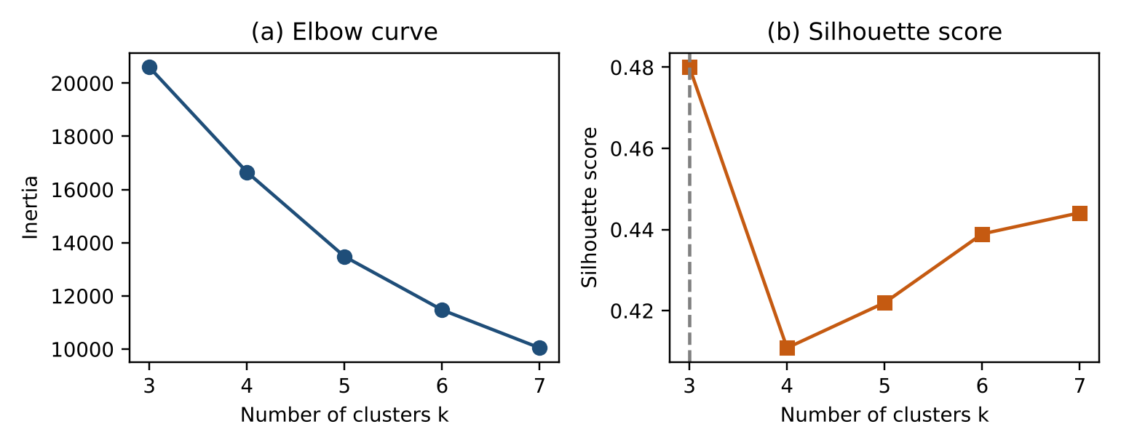
Fig 8.1 Choosing the number of clusters: (a) elbow curve and (b) silhouette score
Segment | Share (%) | REC | FREQ | MON ($) | Churn
Loyal | 13.9 | 39.7 | 7.00 | 298.20 | 0.33
At risk | 28.0 | 191.9 | 2.68 | 103.55 | 0.70
Dormant | 58.1 | 316.6 | 1.08 | 26.73 | 0.91
Table 8.2 Segment profiles (k = 3, silhouette = 0.480)
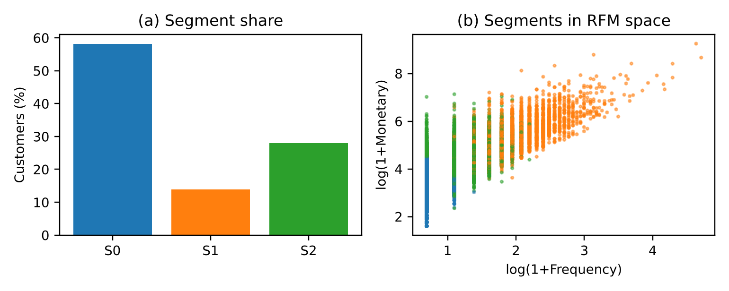
Fig 8.2 Customer segments: (a) share of customers per segment and (b) segments in RFM space

Churn prediction results
The churn classifier results on the held-out test set are given in Table 8.3, and the ROC curve and feature importances in Figure 8.3. The AUC-ROC of 0.803 shows useful ranking ability, and the recall of 0.938 means most churners are caught, at the cost of some false alarms (precision 0.844). Recency and frequency-related features are the strongest drivers, which agrees with the customer-base literature [1].
Metric | Value
Accuracy | 0.818
Precision | 0.844
Recall | 0.938
F1-score | 0.888
AUC-ROC | 0.803
Table 8.3 Evaluation of the churn classifier on the test set
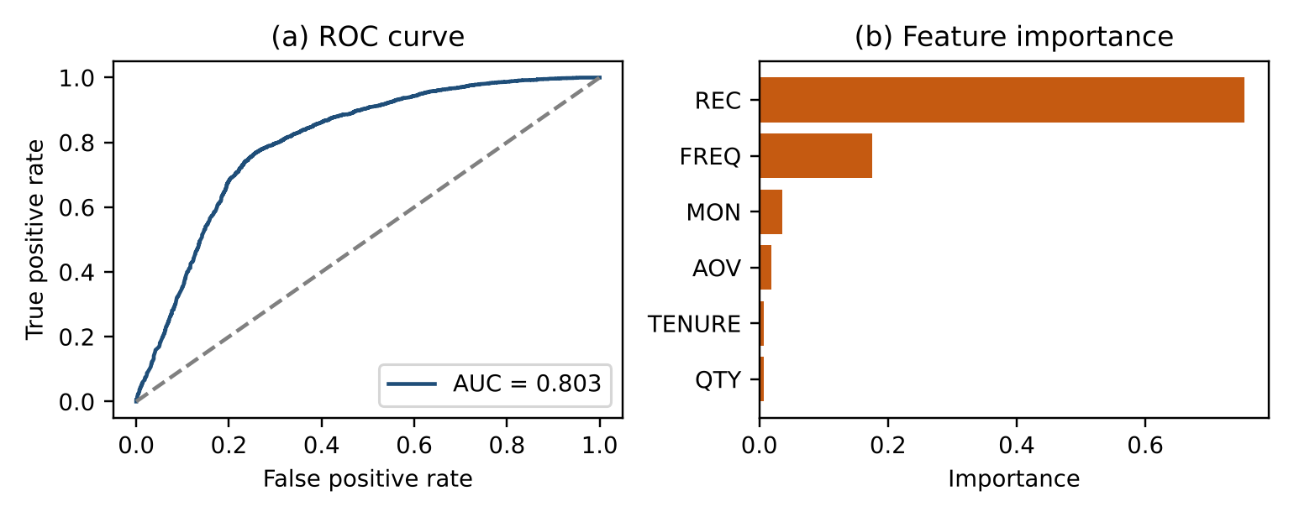
Fig 8.3 Churn model output: (a) ROC curve and (b) feature importance

Demand forecasting results
Table 8.4 compares the forecasters, and Figure 8.4 plots them against the actual weekly revenue. The damped-trend model (MAPE 27.12%) is no better than the naive baseline (27.12%), and both are clearly better than an eight-week moving average (41.34%). This is an honest negative result: the series is dominated by the decay of a single acquisition cohort, and 52 weeks of training data cannot support seasonal terms. It shows why CartCycle always reports forecasts next to a baseline, and that gains from seasonal or decomposable models [14], [15] should be expected only on multi-year, multi-cohort data.
Method | MAPE (%)
Naive (last value) | 27.12
Damped-trend exponential smoothing | 27.12
8-week moving average | 41.34
Table 8.4 Forecast accuracy over 26 test weeks
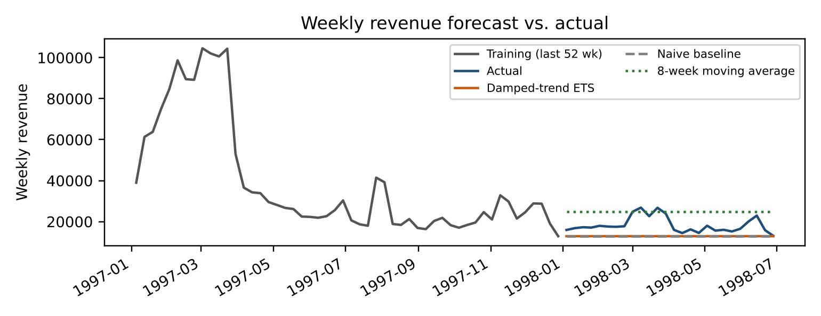
Fig 8.4 Weekly revenue forecast compared with actual values and baselines

CHAPTER 9
Deployment

9.1 Steps to deploy
- Prepare a machine or server with Python 3 and the required libraries (Pandas, NumPy, scikit-learn, statsmodels, Matplotlib and the dashboard framework).
- Copy the CartCycle source code to the server (from the Git repository).
- Place the order data in the configured location, or choose the public CDNOW sample.
- Run the ingestion and cleaning stage so that the storage layer and feature store are created.
- Run the analytics engine to train and score the segmentation, churn, basket and forecasting modules, and register the fitted models.
- Start the dashboard application and open it in a web browser.
- Configure the scheduler so that features and forecasts are recomputed on a regular schedule.

9.2 Environment configuration
Setting | Value / purpose
Data source | CDNOW sample (public) or uploaded CSV file
Cut-off date | 31 December 1997 (features are computed strictly before this date)
Inactivity window | 1 January to 30 June 1998 (no purchase in this window = churned)
Train/test split | 70% / 30%, stratified
Forecast setup | 52 weeks of training, 26 weeks of testing
Monitoring tolerance | Agreed error tolerance that triggers retraining
Privacy | Pseudonymous customer keys; aggregated dashboard outputs by default
Table 9.1 Main configuration settings

9.3 Hosting of frontend and backend
The dashboard and the Python pipeline are part of one application, so they are hosted together. For a demonstration the application runs on a local machine. For a production setting it can be hosted on a cloud or in-house server, with the scheduled retraining job running alongside it. Since the presentation layer only reads finished results, the model runs never block users who are browsing the dashboard. The service layer keeps versioned copies of fitted models, so that a deployment can be rolled back to the previous version when needed.

CHAPTER 10
Challenges & Limitations

10.1 Issues faced during development
- No product or basket information: the CDNOW dataset has no product category or basket information, so the basket-mining module could not be evaluated.
- Class imbalance in churn: churners are the majority class (77.1%), so a classifier that always predicts churn would reach 0.771 accuracy. Accuracy alone is therefore misleading.
- Information leakage: the churn label depends on future purchases, so features must be built only from data before the cut-off date.
- Forecasting on one cohort: the weekly revenue series is dominated by the decay of a single acquisition cohort, and 52 weeks of data cannot support seasonal terms.
- Bulk purchases versus errors: large quantities and unit prices could be either genuine bulk orders or data errors.

10.2 Solutions applied
- Precision, recall, F1-score and AUC-ROC are reported next to accuracy, and the majority-class accuracy is stated explicitly.
- Features are computed strictly before the cut-off, and the split is stratified.
- Every forecast is reported next to naive and moving-average baselines, so a lack of real gain is visible; the negative result is reported honestly.
- Outliers are flagged rather than deleted.
- Where a module cannot run on the loaded data, the dashboard shows a clear message instead of empty output.

10.3 Current limitations or known bugs
- The evaluation uses one public dataset from the late 1990s with no product information, so basket mining and lifetime value still need validation on a modern multi-category store, where the dashboard’s bundle suggestions can also be exercised.
- Output quality depends on the completeness of the source data, and new customers have too little history for reliable estimates (the cold-start problem).
- Churn definitions depend on the inactivity window.
- Observational data cannot prove that an offer caused a customer to stay, so uplift should be confirmed through controlled experiments [20].
- Shapley-value explanations are not yet implemented; explanations currently rely on feature importance.

CHAPTER 11
Future Enhancements

11.1 Planned features
- Streaming architecture for near real-time scoring.
- Personalised recommendation engine for what each shopper sees [16].
- Sequence and survival models for richer customer-behaviour and time-to-churn modelling.
- A/B testing modules to measure whether retention offers really cause customers to stay [20].
- Shapley-value explanations for individual churn predictions [11].
- Privacy-preserving techniques such as federated learning, with scheduled drift monitoring.

11.2 Possible integrations or optimizations
- Validate the pipeline on a modern, multi-category, multi-year store so that bundle suggestions, lifetime value and seasonal or decomposable forecasting models [14], [15] can be exercised.
- Connect storefront exports and databases directly to the ingestion layer.
- Add role-based access control to the dashboard for individual-level customer lists.
- Optimise recomputation using incremental feature updates as data volumes grow.

CHAPTER 12
Conclusion

12.1 Summary of the project
CartCycle shows that customer analytics and sales analytics can be combined into a single, explainable and affordable pipeline that takes a retailer from raw transactions to concrete actions. The pipeline covers validation and cleaning, RFM features, K-means segmentation, gradient-boosted churn prediction with feature-importance explanations, market-basket mining, baseline-checked forecasting and a dashboard with an action layer.

12.2 What was achieved
- On the CDNOW data (23,502 customers), the pipeline and dashboard run end to end.
- The segmentation gives a silhouette score of 0.480 and three clear segments: Loyal (13.9%), At risk (28.0%) and Dormant (58.1%).
- The churn classifier achieves an accuracy of 0.818, F1-score of 0.888 and AUC-ROC of 0.803 on a held-out set, with recency and frequency as the strongest drivers.
- The forecasting experiment showed the need for baseline checks: the damped-trend model did not beat the naive baseline on this single-cohort series.
- The dashboard turns results into a downloadable priority retention list ranked by value at risk and a restocking panel.

12.3 Skills learned during development
- Data cleaning and validation, and building features without information leakage.
- Unsupervised learning and cluster validation with elbow and silhouette analysis.
- Supervised learning on imbalanced data, and choosing metrics beyond accuracy.
- Time-series forecasting and the importance of honest baseline comparison.
- Designing a layered, modular system and an interactive dashboard that leads to decisions.
- Responsible handling of customer data and writing a technical report.

CHAPTER 13
References
[1] P. S. Fader, B. G. S. Hardie, and K. L. Lee, “RFM and CLV: Using iso-value curves for customer base analysis,” J. Marketing Research, vol. 42, no. 4, pp. 415–430, 2005.
[2] P. S. Fader, B. G. S. Hardie, and K. L. Lee, “‘Counting your customers’ the easy way: An alternative to the Pareto/NBD model,” Marketing Science, vol. 24, no. 2, pp. 275–284, 2005.
[3] D. C. Schmittlein, D. G. Morrison, and R. Colombo, “Counting your customers: Who are they and what will they do next?” Management Science, vol. 33, no. 1, pp. 1–24, 1987.
[4] S. P. Lloyd, “Least squares quantization in PCM,” IEEE Trans. Inf. Theory, vol. 28, no. 2, pp. 129–137, Mar. 1982.
[5] A. K. Jain, “Data clustering: 50 years beyond K-means,” Pattern Recognition Letters, vol. 31, no. 8, pp. 651–666, 2010.
[6] P. J. Rousseeuw, “Silhouettes: A graphical aid to the interpretation and validation of cluster analysis,” J. Computational and Applied Mathematics, vol. 20, pp. 53–65, 1987.
[7] D. Chen, S. L. Sain, and K. Guo, “Data mining for the online retail industry: A case study of RFM model-based customer segmentation using data mining,” J. Database Marketing & Customer Strategy Management, vol. 19, no. 3, pp. 197–208, 2012.
[8] T. Chen and C. Guestrin, “XGBoost: A scalable tree boosting system,” in Proc. 22nd ACM SIGKDD Int. Conf. Knowledge Discovery and Data Mining, San Francisco, CA, USA, 2016, pp. 785–794.
[9] L. Breiman, “Random forests,” Machine Learning, vol. 45, no. 1, pp. 5–32, 2001.
[10] J. H. Friedman, “Greedy function approximation: A gradient boosting machine,” Ann. Statist., vol. 29, no. 5, pp. 1189–1232, 2001.
[11] S. M. Lundberg and S.-I. Lee, “A unified approach to interpreting model predictions,” in Advances in Neural Information Processing Systems 30 (NeurIPS), Long Beach, CA, USA, 2017, pp. 4765–4774.
[12] R. Agrawal and R. Srikant, “Fast algorithms for mining association rules,” in Proc. 20th Int. Conf. Very Large Data Bases (VLDB), Santiago, Chile, 1994, pp. 487–499.
[13] J. Han, M. Kamber, and J. Pei, Data Mining: Concepts and Techniques, 3rd ed. Waltham, MA, USA: Morgan Kaufmann, 2012.
[14] R. J. Hyndman and G. Athanasopoulos, Forecasting: Principles and Practice, 2nd ed. Melbourne, Australia: OTexts, 2018.
[15] S. J. Taylor and B. Letham, “Forecasting at scale,” The American Statistician, vol. 72, no. 1, pp. 37–45, 2018.
[16] F. Ricci, L. Rokach, and B. Shapira, Eds., Recommender Systems Handbook, 2nd ed. New York, NY, USA: Springer, 2015.
[17] F. Pedregosa et al., “Scikit-learn: Machine learning in Python,” J. Machine Learning Research, vol. 12, pp. 2825–2830, 2011.
[18] S. Seabold and J. Perktold, “Statsmodels: Econometric and statistical modeling with Python,” in Proc. 9th Python in Science Conf., 2010, pp. 92–96.
[19] C. Davidson-Pilon, “Lifetimes: Customer lifetime value in Python (bundled CDNOW transaction sample),” GitHub repository. Available: https://github.com/CamDavidsonPilon/lifetimes.
[20] R. Kohavi, D. Tang, and Y. Xu, Trustworthy Online Controlled Experiments: A Practical Guide to A/B Testing. Cambridge, U.K.: Cambridge Univ. Press, 2020.

CHAPTER 14
Appendices

14.1 Screenshots of the application
The screenshots of the dashboard are given in Figure 6.1 (main page with indicators, revenue trend and segment share) and Figure 7.1 (action layer with the priority retention list, CSV export, and restocking and bundle panel).

14.2 Sample code snippets
The following snippets illustrate the core computations of the pipeline (simplified for readability).

(a) RFM feature engineering
import pandas as pd, numpy as np
cutoff = pd.Timestamp('1997-12-31')
tx = tx[tx['date'] <= cutoff] # no information leakage
rfm = tx.groupby('customer_id').agg(
REC=('date', lambda d: (cutoff - d.max()).days),
FREQ=('date', 'nunique'),
MON=('amount', 'sum'))
rfm['AOV'] = rfm['MON'] / rfm['FREQ']

(b) Segmentation with K-means and the silhouette score
from sklearn.preprocessing import StandardScaler
from sklearn.cluster import KMeans
from sklearn.metrics import silhouette_score
X = StandardScaler().fit_transform(np.log1p(rfm[['REC','FREQ','MON']]))
for k in range(3, 8):
labels = KMeans(n_clusters=k, n_init=10, random_state=42).fit_predict(X)
print(k, silhouette_score(X, labels))

(c) Churn model and value at risk
from sklearn.ensemble import GradientBoostingClassifier
from sklearn.model_selection import train_test_split
Xtr, Xte, ytr, yte = train_test_split(feat, churn, test_size=0.30, stratify=churn)
model = GradientBoostingClassifier().fit(Xtr, ytr)
proba = model.predict_proba(feat)[:, 1]
feat['VALUE_AT_RISK'] = proba * feat['MON'] # priority retention ranking

(d) Forecast evaluation against baselines
def mape(y, yhat): return np.mean(np.abs((y - yhat) / y)) * 100
naive = np.repeat(train.iloc[-1], len(test))
print('Naive MAPE', mape(test.values, naive))

14.3 Installation/setup instructions
- Install Python 3 and create a virtual environment.
- Install the dependencies: pandas, numpy, scikit-learn, statsmodels, matplotlib and the dashboard framework (for example with pip).
- Obtain the source code and place the dataset (or choose the CDNOW sample).
- Run the pipeline to clean the data, build features and train the models.
- Launch the dashboard application and open the displayed address in a web browser.

14.4 User manual or guide
- Choose the data source in the sidebar: the CDNOW sample (public) or Upload CSV.
- Set the date range and select the customer segments (At risk, Dormant, Loyal) to analyse.
- Read the indicator row (revenue, orders, average order value, customers, average churn risk) for the headline view.
- Use the tabs (Overview, Segments, Churn, Sales & forecast, Data quality) to move from a number to its cause.
- In the action layer, review the priority retention list and press Download retention list (CSV) to share it with the campaign team.
- Check the restocking and bundles panel; a message is shown when a flag or bundle suggestion is not available for the loaded data.

14.5 Certifications
[Attach the course, workshop or certification certificates of the team members here.]

